In the space preceding each of the following statements, write an O for things that are OK in a friendship, D for maybe OK depending on the circumstances or an N for not OK.

1. A friend accepts me just as I am, without trying to change me.
2. A friend finds ways to show that I’m important to him/her.
3. A friend is interested in the same things that interest me.
4. A friend never pressures me to do something I don’t want to do.
5. A friend does not criticize me in front of other people.
6. A friend can be trusted to tell me the truth, no matter how bad.
7. A friend is willing to break rules to help me out.
8. A friend never reveals my secrets.
9. A friend never has to prove anything to me.
10. A friend shares anything he/she has with me.
11. A friend is loyal and backs my position at all times.
12. With a friend I am able to behave any way I want, and he/she will understand.

HOW TO BE ASSERTIVE  
WITH A FRIEND

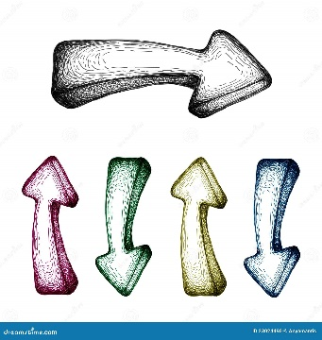

* State your position
* Repeat your position, but stay friendly
* Stand up for yourself, refuse to take blame or guilt
* Walk away